:
NEWS RELEASE
FOR IMMEDIATE RELEASE  7/20/2021 | Contact: Sydney Latimer  Girl in Ties Designs  323.396.2526  girlinties@gmail.com  girlinties.com
RONDO COMMUNITY NATIVE PRODUCES DOCUMENTARY FILM
ST. PAUL, MN - Artist, writer, and activist Sydney Latimer (them/they - aka Divinewords) begins production of their newest project: The Uses of Anger: A Community Responding to Heartache.

The Uses of Anger is a 30-minute documentary film and online community project that chronicles Sydney’s journey as they embark on a new life path as a non-traditional student and shrine maker. Latimer explores the role that shrines, memorials, and rituals play in the understanding of the human condition through provocative acts of remembrance, as a form of street art. Sydney struggled to navigate feelings of anger after their father died suddenly from complications of pancreatic cancer in 2015 and found macabre art as an outlet for their grief.

This film features Rondo, Frogtown, and Midway community members expressing their feelings about rampant street violence, gentrification, and state abuse in the wake of civil unrest amid a global pandemic. The documentary highlights the resilience of these neighborhoods as they transmute their anger through artistic expression and enterprise.

Latimer was awarded the Artist Neighborhood Partnership Initiative Grant (CURA/The University of Minnesota) and the Science Museum of Minnesota “RACE Grant” to fund production of The Uses of Anger. Sydney’s creative design firm, Girl in Ties, has partnered with Miki Lewis, founder of the 8218/Truce Center, as a community partner for the project. The cast features local artists, organizers, and business owners that are dedicated to rebuilding the Rondo and Frogtown communities. Filmmaker, Angel Oquendo, has traveled to Minnesota to direct the film. The Uses of Anger poses two questions: What makes you angry? Now, what are you going to do about it?

For media queries, press kit, or more information please contact girlinties@gmail.com.
- MORE -
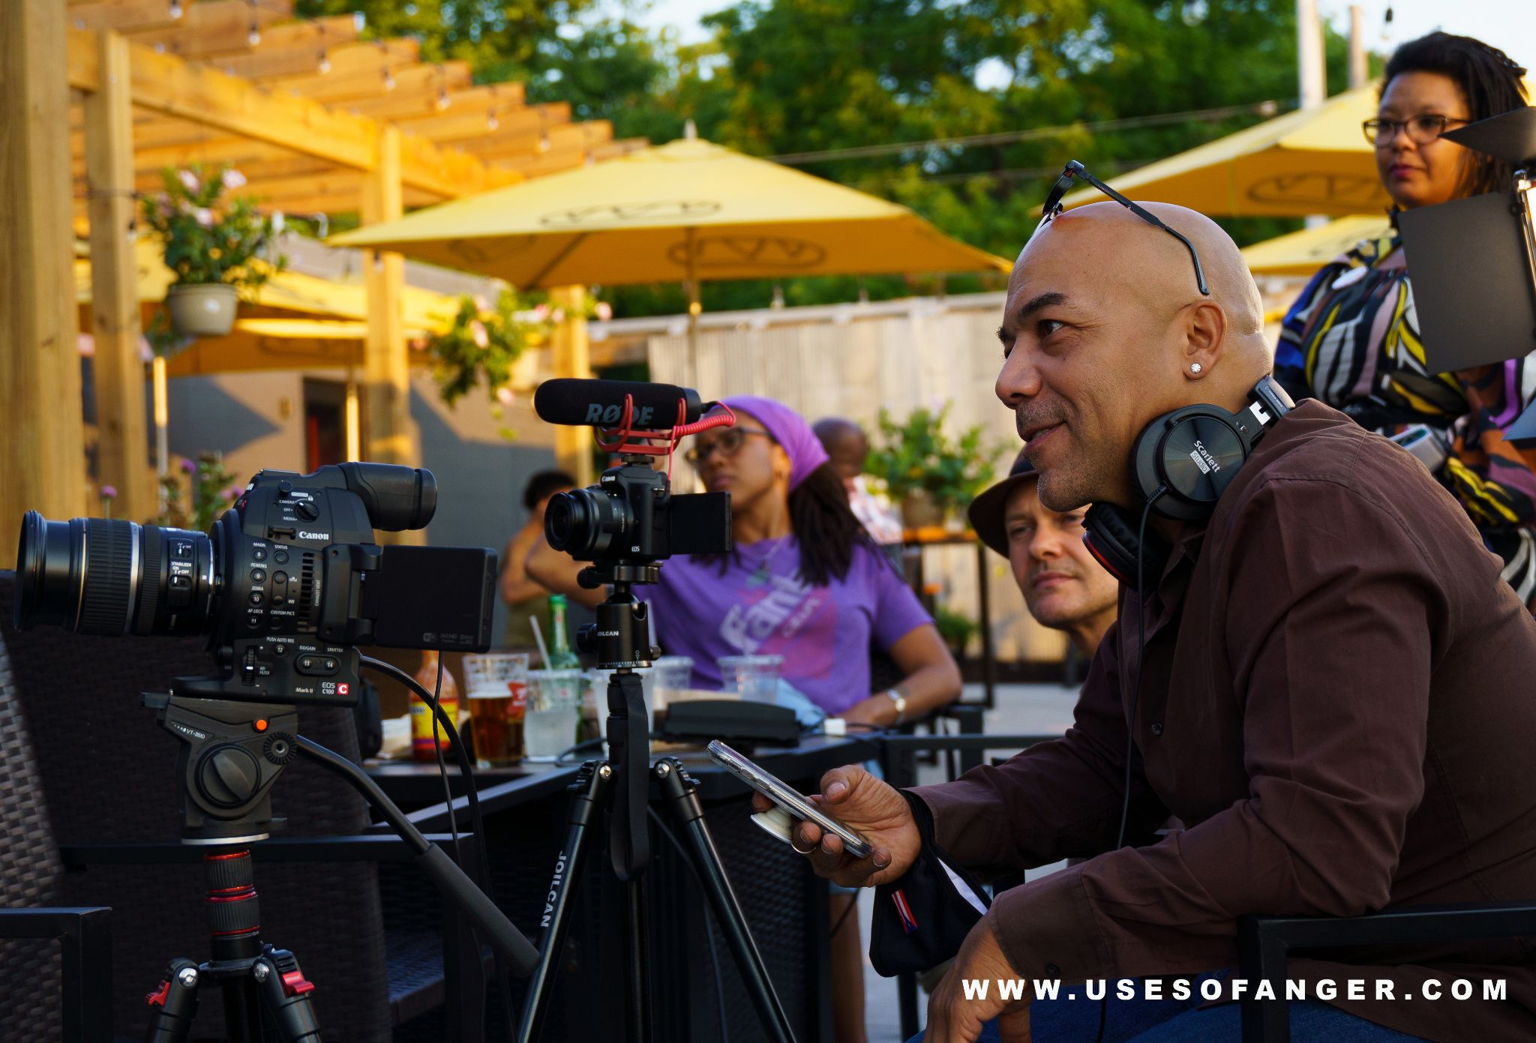
Written and Produced by Sydney Latimer (Divinewords)
Directed by Angel Oquendo
Camera by Anthony C. Dalton
Still Photography by Andre Ahyai
Edited by Toki Wright
Music by deVon Russell Gray and Queen Drea Tolson
Backdrop Art by Meyer Warren (St. Paul Slim)
​
www.usesofanger.com
www.girlinties.com

#rondo #community #minnesota #twincities #stpaul #minnesotafilmmakers #documentary #blackfilmmakers #queerfilmmakers #blackfilmaker #queerfilmmaker #victoriatheater #cura #universityofminnesota #sciencemuseumofminnesota #trucecenter #art #dance #murals

###

